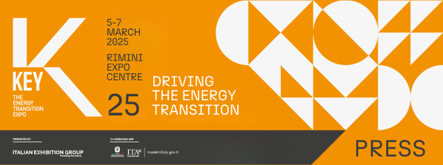

press release
(English translation)

IEG: KEY – THE ENERGY TRANSITION EXPO AND HANNOVER MESSE
THE HYDROGEN SHOW SUPPORTED BY HYDROGEN & FUEL CELLS IS BORN IN RIMINI

- A cooperation agreement has been signed for the joint organisation of the Show as part of the next editions of KEY.
- For the first time at Rimini Expo Centre from 5th to 7th March 2025 as part of Italian Exhibition Group’s event on energy transition and efficiency.

Rimini, 24 June 2024 - Hydrogen, especially electrolysis-derived green hydrogen fuelled by clean energy, is crucial for achieving decarbonisation targets: the European Union plans to reach 20 million tonnes by 2030, 10 million of which will be produced and the other half imported.

With a view to enhancing the crucial role of hydrogen in reducing polluting emissions and with the common aim of contributing to accelerating the development of the sector, Italian Exhibition Group and Hannover Fairs International GmbH (HFI), the Italian branch of Deutsche Messe AG, have signed a collaboration agreement for the joint organisation of a new Hydrogen Show supported by Hydrogen & Fuel Cells as part of KEY - The Energy Transition Expo, IEG's event on energy transition and efficiency, a reference point in Southern Europe, Africa and the Mediterranean basin, whose next edition is scheduled to take place at Rimini Expo Centre from 5th to 7th March 2025.

Hydrogen & Fuel Cells EUROPE is organised and managed by Deutsche Messe AG (DMAG), the German trade show company among the world leaders. It takes place during Hannover Messe, Europe's most important exhibition for industry and automation, and deals with the entire life cycle of hydrogen - in particular green hydrogen as a substitute for fossil fuels - in the context of sustainable industrial transformation.

The Hydrogen Show supported by Hydrogen & Fuel Cells aims to become the privileged place on a global scale for discussion on hydrogen issues and its importance for the energy transition, as well as a moment of reference for the main players involved at which to meet, exchange views and support the creation of new projects. The Show is the natural evolution and reinforcement of the KEY exhibition area dedicated to hydrogen, its applications and the great opportunity that this vector can offer for decarbonising hard-to-abate industrial and transport sectors.

“We have always believed in the potential of hydrogen, which is why we included it in the exhibition areas of KEY from the very beginning. We are proud to announce today a new joint-venture with a partner of great relevance and experience such as Hannover Fairs International GmbH, which, as of the next edition of KEY, will allow us to further strengthen the presence of hydrogen within our event with its own specific exhibition, destined to become a reference point at international level," commented Corrado Peraboni, CEO of IEG.

“For almost 30 years, Deutsche Messe AG has been organising Hydrogen + Fuel Cells EUROPE, a successful format where all market players can exchange ideas each year as part of Hannover Messe. Germany and Italy are the most important industrial partners in Europe and share a common vision of hydrogen. We are therefore proud to be able to work together with IEG to create positive synergies and an innovative and attractive platform in Italy," said Andreas Züge, General Manager of Hannover Fairs International GmbH, Italian Branch.

ABOUT KEY 2025
Event: International trade show; Organisation: Italian Exhibition Group S.p.A.; Frequency: annual; Edition: 3rd; Dates: 5-7 March 2025; mail keyenergy@iegexpo.it; Website: http://www.key-expo.com; Facebook: https://www.facebook.com/keyexpo/; Twitter: https://twitter.com/KeyEnergyit; LinkedIn: https://www.linkedin.com/company/keyenergy/

PRESS CONTACT KEY - ITALIAN EXHIBITION GROUP
head of media & corporate communication: Elisabetta Vitali; press office manager: Marco Forcellini, Pier Francesco Bellini; international press office coordinator: Silvia Giorgi; press office specialists: Luca Paganin, Nicoletta Evangelisti, Mirko Malgieri; media@iegexpo.it

MEDIA AGENCY: Smartitaly Communications
Sara Scatena, s.scatena@smartitaly.it, mob. +39 338 7836985; Arianna Geli, a.geli@smartitaly.it, mob. +39 347 0917903

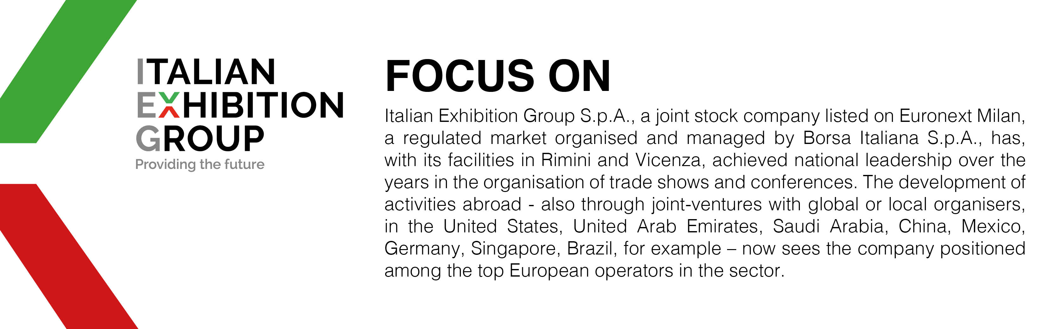

This press release contains forecast elements and estimates that reflect the management´s current opinions (´forward-looking statements´), particularly regarding future management performance, realization of investments, cash flow trends and the evolution of the financial structure. For their very nature, forward-looking statements have a component of risk and uncertainty, as they depend on the occurrence of future events. The effective results may differ (even significantly) from those announced, due to numerous factors, including, only by way of example: food service market and tourist flow trends in Italy, gold and jewellery market trends, green economy market trends; the evolution of raw material prices; general macroeconomic conditions; geopolitical factors and evolutions in the legislative framework. Moreover, the information contained in this release, does not claim to be complete, and has not been verified by independent third parties. Forecasts, estimates and objectives contained herein are based on the information available to the Company as at the date of this release.

